Carthage College Refund Policy

Definitions:
Charge: Costs that you owe to Carthage, such as tuition, fees, housing (if living on campus), dining, and any other expenses that you incur during the semester. Charges appear as a positive number on Nelnet.

Credit: Funds added to your account to pay off your balance. Credits include Carthage Aid, outside scholarships, grants, loans, and any payments to your account. Credits appear as a negative number on Nelnet.

Credit balance: The funds remaining when the total credits posted to a student’s account exceed the charges applied for a specific term or semester. Students may use a Credit Balance on their account for a subsequent term or semester by filling out and submitting the Credit Balance Authorization Form to the Office of Student Financial Services.

Nelnet credit refund: Students can request a refund for credits that remain on their account via their Nelnet portal after billing is complete for a term. Before requesting a refund for a credit balance, students must fill out and submit the Credit Balance Authorization Form to the Office of Student Financial Services.

Refund Process:
Students who have payments exceeding charges may be eligible for the issuance of a credit refund. Credit refunds can be requested following the official disbursement of funds. Students who have payments exceeding charges may fill out a Credit Balance Authorization Form to request these overpayments back, or they can choose to leave the credit on their account for future charges. Credit refunds are processed once a week on a rolling basis following disbursement.

All credit refunds are returned through the NelNet payment system. Students can choose the method that they would like to receive their refund back through the “Manage Refunds” option in the NelNet system. Students will be notified from NelNet on the status of their refund via Carthage email.

Students with credit balances following disbursement are contacted with instructions on how to request the credit balance back or the option to leave the credit in their student account for future charges.
Credit balances generated by Parent plus loans are processed on a different schedule. Please see that section below.

Student who withdraw from the semester may be eligible for a refund. Refunds are based on the date of withdrawal and prorated. Please see the types of withdraw and proration schedule below.

Types of Withdrawal:

Complete Institutional Withdrawal: Students who wish to withdraw from the institution must contact their assigned student success advisor in the Center for Student Success. Your advisor will complete and submit the Institutional Withdrawal Form to the Office of the Registrar. The date this form is received determines the official withdrawal date applied toward the refund policy. In the event of unforeseen circumstances, such as severe illness or events beyond the student’s control, the College may use a withdrawal date determined by the student’s last date of attendance at an academically related activity, as documented by the College. Failure to follow the process of an official withdrawal can result in an unofficial withdrawal. Resident students must work with Residential Life staff to vacate their assigned rooms within 48 hours of the receipt of withdrawal forms. Extenuating circumstances will be considered by the Residential Life staff.

Unofficial Withdrawal: If faculty report inadequate attendance by the third week of the semester, students will be unofficially withdrawn from the institution. This date is determined by the last known date of academic activity and will coincide with the refund policy. Students who fail to maintain consecutive registration will be unofficially withdrawn from the institution following the add/ drop date of the subsequent term.

Administrative/Disciplinary Withdrawal: Under certain circumstances students may be involuntarily withdrawn from the institution. These circumstances could include, but are not limited to, disciplinary action due to student behavior, failure to consistently attend classes for more than three weeks without an excused absence, and faculty confirmation of excessive missing assignments. In the case of administrative/disciplinary withdrawal, student refunds will be prorated based on the date of the administrative/disciplinary withdrawal.

Withdrawal Refund Schedule:
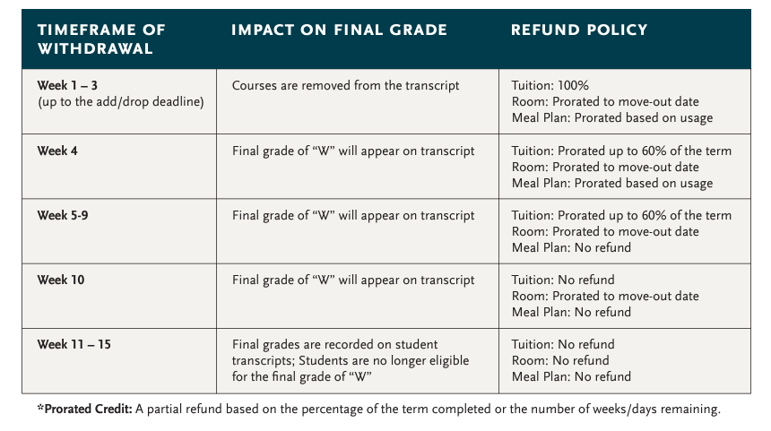

Parent Plus Loans:
The Federal Direct PLUS Loan allows a parent to borrow money for the educational expenses of a child who is a dependent undergraduate student enrolled at least half-time. PLUS Loan funds are disbursed to the student’s account at the beginning of each semester. The loan amount will be divided evenly between each semester of enrollment during the academic year unless the payment it selected to be applied only to one semester. Federal Parent PLUS Loans may create a credit on a student account. This credit can be refunded to the student or the parent. The parent borrower makes the selection on the PLUS loan application. These refunds are issued back as indicated by the borrower through the NelNet system. If there is a credit generated by a Parent plus loan this credit will be refunded within two weeks of disbursement.

